**5 metrics on the MSIS program:**

Prospective students evaluate number of different alternatives and options while considering and applying for a graduate degree admission. The most important metrics for choosing MSIS graduate program are: tuition fees, ranking, location, curriculum, alumni and post-graduation employment opportunities especially for the international students who want to realize their American dream and aspire to get hired by a leading tech firm in Silicon Valley. Five of the metrics to be used in our data visualization are as follows:

* Ranking
* Curriculum & MS degree comparison
* Alumni profile
* Post- graduation employment opportunities
* Salaries related to the desired occupation in the field

Prospective students narrow down their ranking metric to at least a top schools ranking in California. This metric is categorized to an extent and it further distinguishes among the public, regional, western and program related rankings. Students interested in the MSIS program at Santa Clara University, search for the rankings of the program and after selecting their choice, further evaluates the other metrics as mentioned above.

When a prospective student selects Santa Clara University, they may also evaluate the curriculum and other options under the MS Degree Comparison webpage which I read in Python using Beautiful Soup package utilizing the HTML thread of the table. This metric is important because an international student has work related restrictions and privileges after graduation, however, MSIS program at SCU is a STEM extension approved program by the USCIS , therefore the MS comparison table on the SCU website is a decent metric for a prospective student.

One of the vital metrics is salaries indicator of MSIS graduates, who often search for Data Analyst roles. The Fig 1.1 below shows the salary distribution in a Tableau bubbles graph, the size of the bubble shows the salary amount offered by the company. Fig 1.1 shows that Microsoft offers the highest remuneration followed by Cisco and TCS.

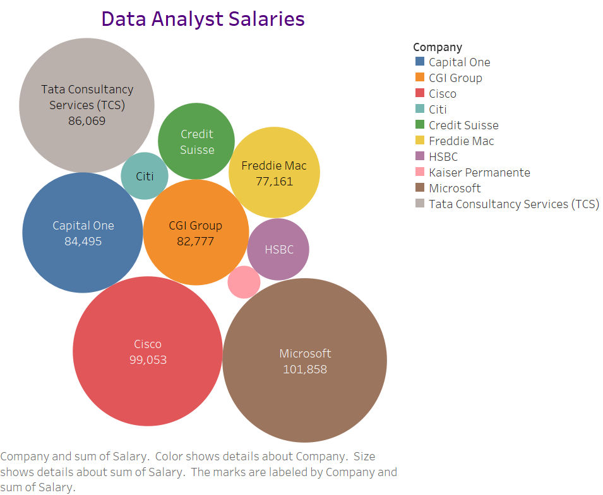

**Fig 1.1**

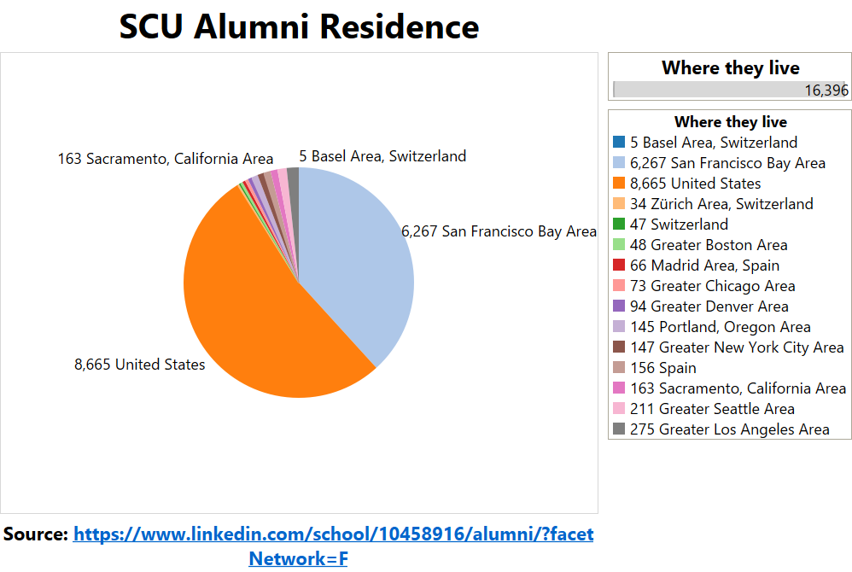

**Fig 1.2**

Another important metric is Fig 1.2 which shows the SCU Alumni profile and their location of residence. The tableau visual shows that a majority of SCU MSIS graduates are located and working in Silicon Valley technology firms. This also indicates that recruiters and companies are interested in hiring SCU graduates, further highlighting the quality and recognition of the SCU MSIS program for the interested prospective students. Therefore, alumni profile is an important indicator for evaluating a certain graduate degree of a university under consideration.

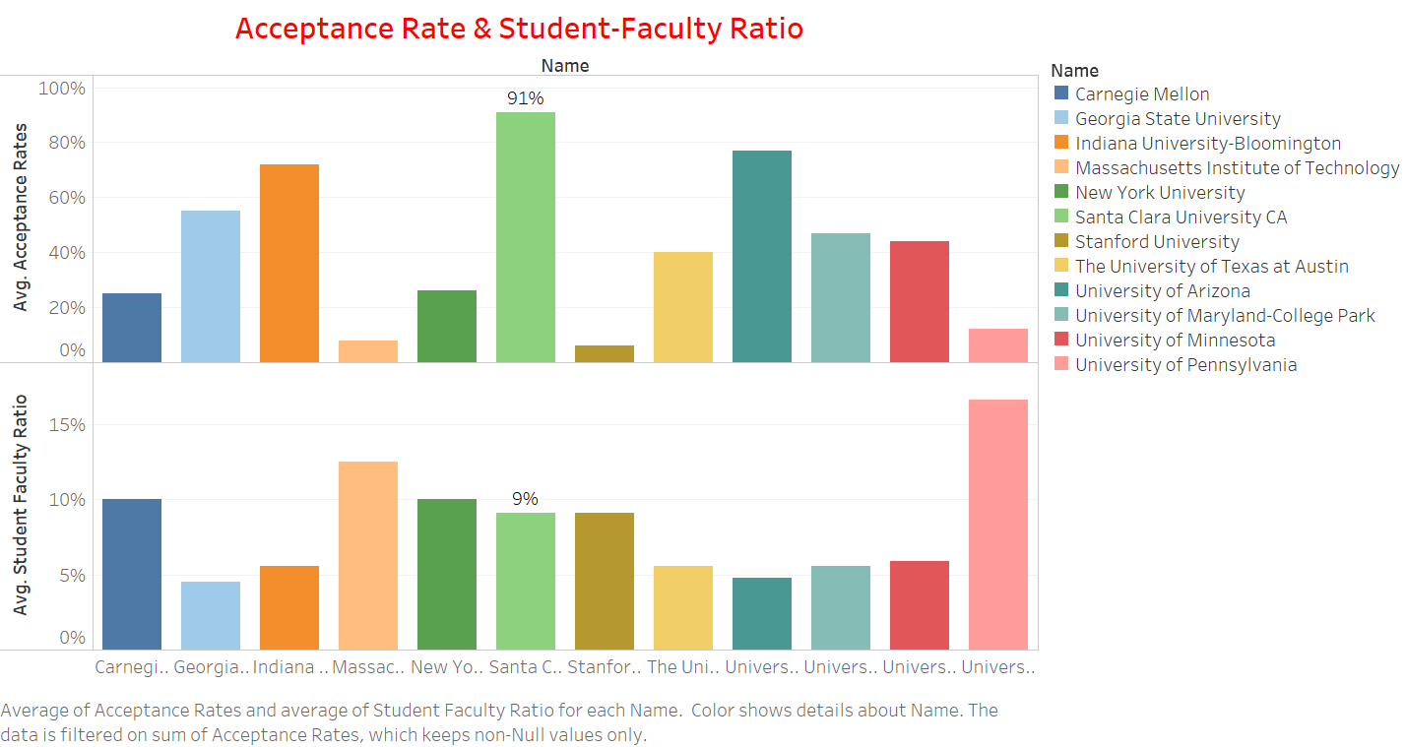

**Fig 1.3**

Another crucial criteria of evaluating SCU MSIS program is to analyze the acceptance rate and student to faculty ratio of the graduate degree. Santa Clara University has a very welcoming acceptance rate and thus motivating prospective students to consider and apply for admission. This is shown above in Tableau visual Fig 1.3, SCU acceptance rate is 91%.Secondly, SCU is very student focused institution and therefore, offers student faculty ratio of 9%.